**Assignment 3 report**

Step1) copy 2 folders(aliceTTT,bobTTT) in the ubuntu desktop, Alice will be aliceTTT and Bob will be bobTTT:

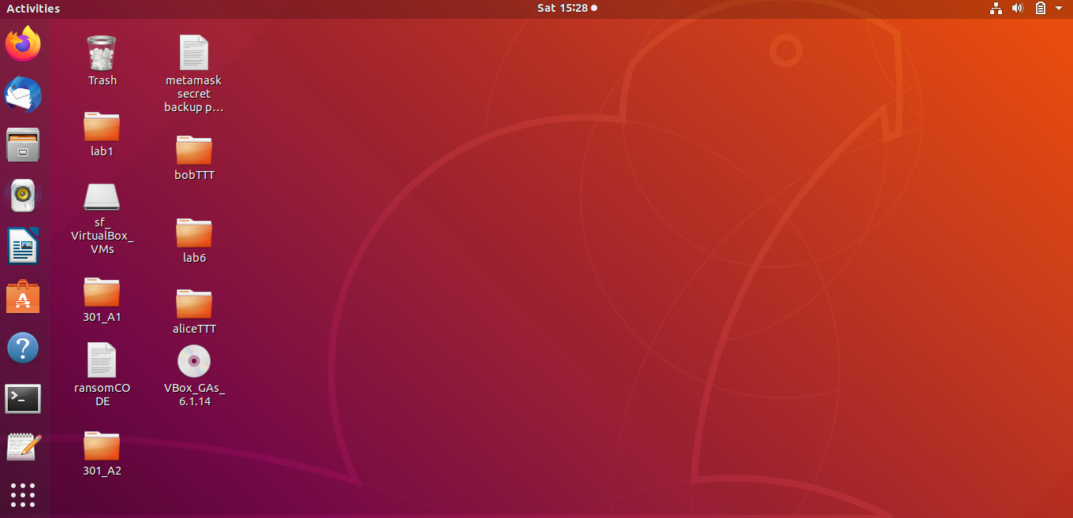

Step2) Open 2 terminals, cd one terminal to ‘aliceTT’ and the other terminal to ‘bobTTT’. aliceTTT has 2 files, alicejson.py and block0.json. bobTTT has one file, bobjson.py:

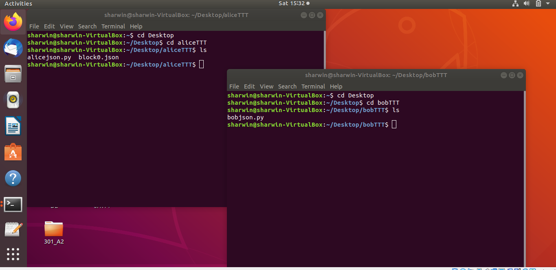

Step 3) First run bobjson.py. This ensure Bob is ready to receive the data from Alice as, she will make the first move in the tic tac toe game. Upon running the file , “Bob is ready” will be displayed to signify Bob is ready :

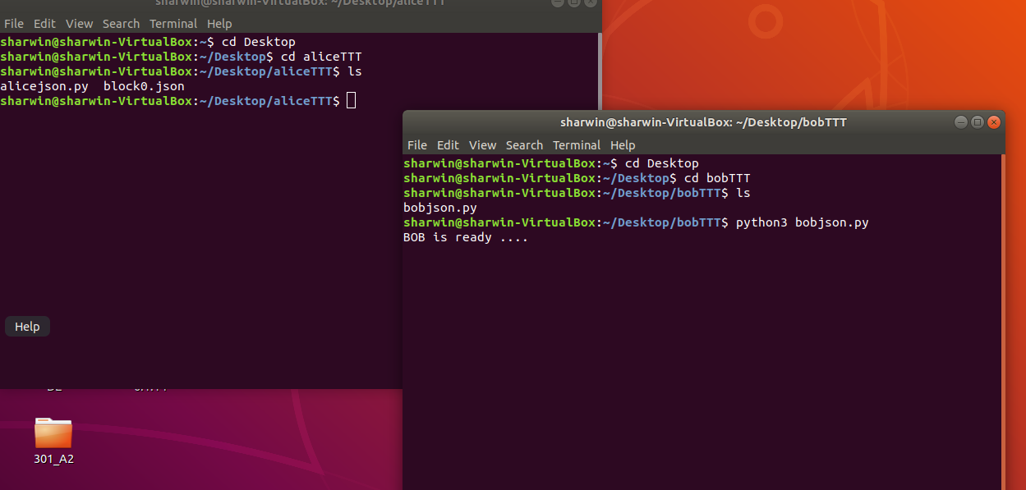

Step 4) Run alicejson.py(Alice) to start the game. No manual input is required and the entire game is simulated. Upon running alicejson.py, both terminals will display the blocks being transferred as well as the mining process being executed :

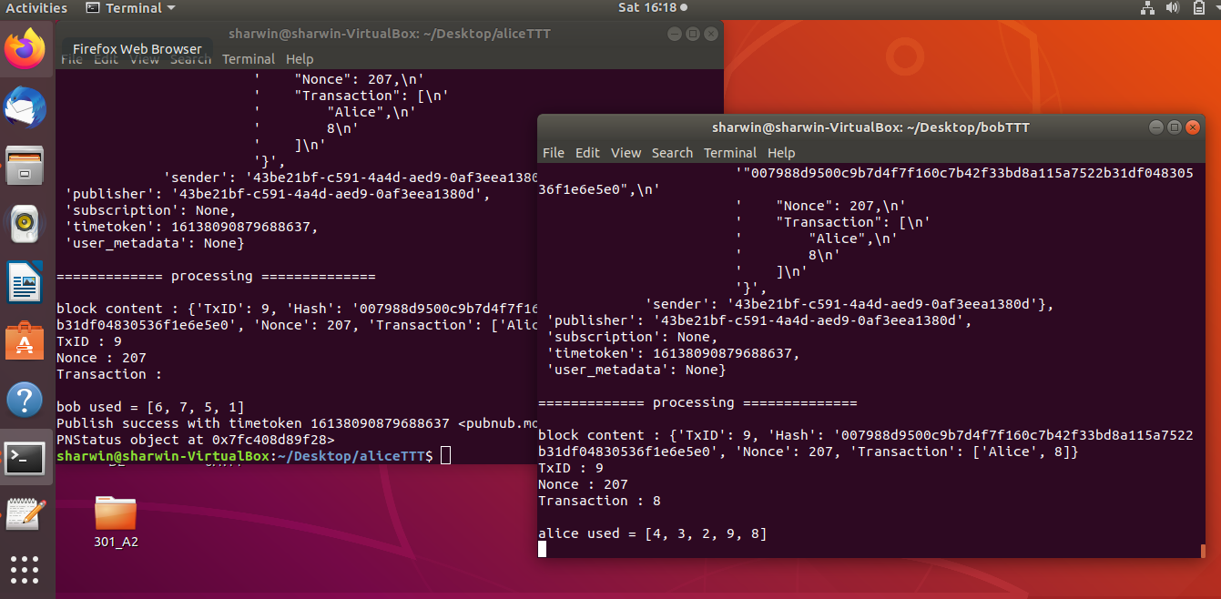

Step 5) Go to Desktop and open both aliceTTT and bobTTT folder. aliceTTT will contain 10 .txt files and bobTTT will have 9 .txt files. These are the history of the blocks being transferred. In each .txt file , it contain the data of the block that was being transferred:

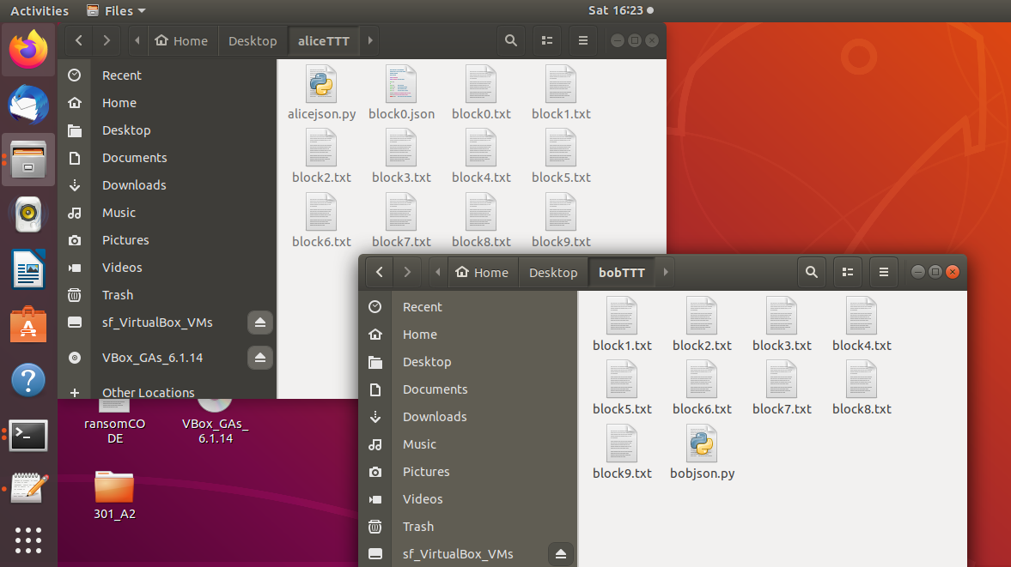

Example of the block data :

From aliceTTT:

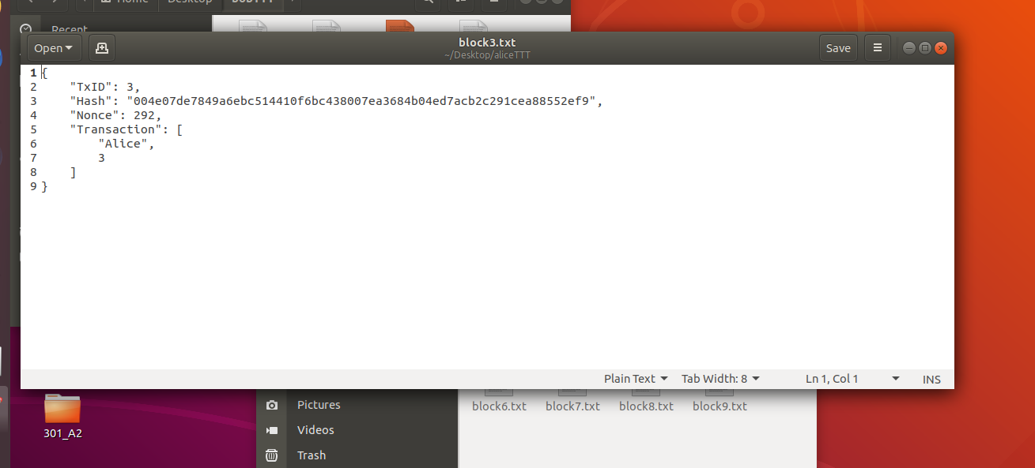

From bobTTT:

